# Parts Appendix B: Parts Costing Methods

### Replacement Cost: With this technique, the most recent published cost is used as the cost for all units in inventory. More than 95% of HBS dealerships use this method of costing.

### Advantages:

* The stored cost can be easily validated by comparing it with the vendor price
* Price Update and Variance updates inventory costs nightly
* PUV reports all inventory valuation changes
* Easily handles DS01 pricing and costs based on list price
* Avoids increased tax burden in periods of inflation

### Disadvantages:

* May increase or decrease inventory valuation even without on-hand changes
* Some businesses do not use replacement cost accounting

### Average Cost: Average costing is an alternative method of computing the cost basis for inventory. Most US dealerships cannot easily change to average costing as it requires a change in accounting status with the IRS.

### Advantages:

* Levels out the effect of cost changes over time.
* Can more accurately account for historical costs without the complexity of individual part cost tracking

### Disadvantages:

* Inventory value adjustments happen one part at a time - not a bulk process

All parts that have an average cost will be subject to **average cost recalculation**. Average cost parts will also have pricing source-factored based on the average cost (where appropriate.)

### Programs that Initialize Average Cost: Each part added to inventory from a price file must have average cost initialized if average costing is enabled. It is the responsibility of the user to set the average cost on parts added through PMM or CPM. The programs will not automatically copy the manufacturer cost into the average cost field as is done with parts added from a price file.

### Calculation of Average Cost: The method is straightforward:

* The on hand quantity is multiplied by the Average Cost.
* The number of parts to add to inventory is multiplied by the new replacement cost.
* The two dollar amounts are added together.
* The on hand quantity is incremented by the additional number of parts.
* The dollar total is then divided by the total number of units now on hand giving the new Average Cost.

### Programs that Recalculate Average Cost: Every program that increases inventory triggers a new cost average.

* Quick receipt - user entered value
* Automatic receipt - complicated by multiple parts
* Customer part return - for now, use current average cost
* Voided picking ticket - use cost stored in ticket
* Transfer between locations - use cost from sending location
* Custom part on-hand adjustment
* Part master on-hand adjustment
* Physical inventory count adjustment
* Post Inventory Adjustments

### Price Update and Variance will not affect average cost. Variance Report will not print inventory valuation change if Average Costing is in effect.

### Average Cost Implementation—cost application

### PMM: The average cost field may be viewed and edited with this program. Changes to the on-hand or on-order quantities will not affect the average cost, and the program will not prompt for a new cost if either of these quantities are modified. NOTE: This field is password-protected, requiring the same password that “unlocks” the Qty On Hand field.

### Custom Prompts (INCP/CPM):

### INCP: The Average Cost field should be added in INCP when Average Costing is enabled.

* **CPM:** The Average Cost field may be edited with CPM. Changes to the on-hand or on-order quantities will not affect the average cost, and the program will not prompt for a new cost if either of these quantities are modified. If Average Costing is enabled, the average cost will be shown below the Manufacturer Cost field in the information box.

### Part Inquiry (PI): The Average Cost field will be displayed only if average costing is activated. It will appear directly beneath the Mfr cost field. The display (F8) of average and manufacturer cost will both be controlled by the Cost flag in IPOS.

### Price File Inquiry (PFI): The prices shown have traditionally been those retrieved from the price file; this is the means for seeing manufacturer prices independently from the prices stored in the Part Master. However, the prices shown are source-factored, so they are not, strictly-speaking, the manufacturer prices. The average cost will not be presented in this view because the manufacturer cost takes precedence. PFI must still recognize that average costing is enabled since parts added from the price file must initialize the average cost.

### Practical Application of Average Cost: When Average Cost is turned on the IPOS screen under the Inv Defaults tab will show Average Cost active.

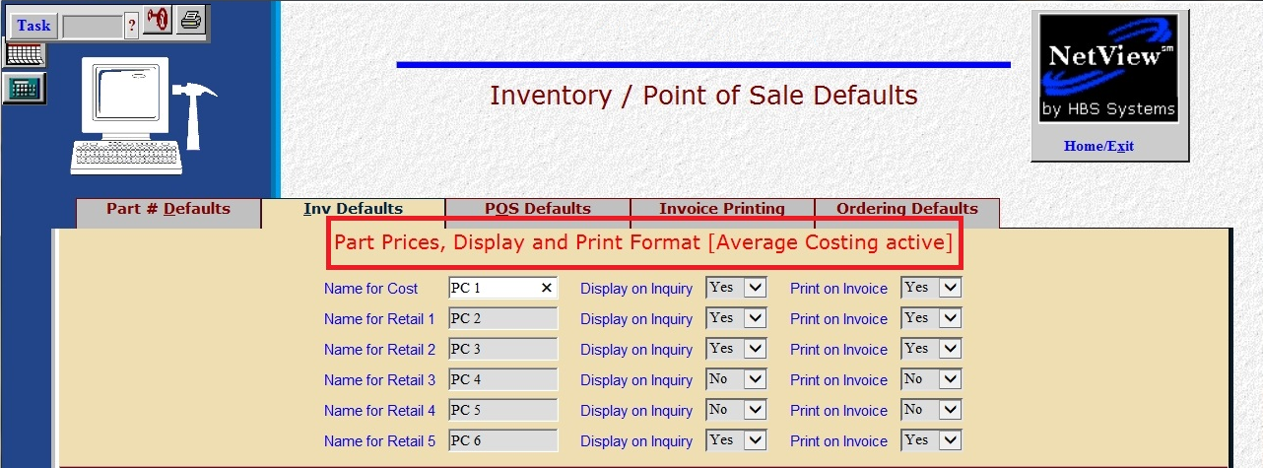

You have a choice to change the Mfr Cost when the part is received in. The switch is in IPOS under Inv Defaults. **HBS recommends “No” as the Mfr Cost will be overwritten with price file updates.**

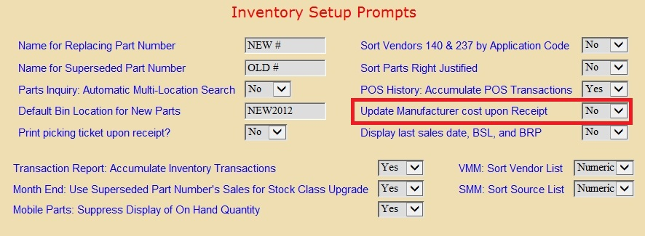

Here is an example of a part in PMM. Notice the field for Avg Cost.

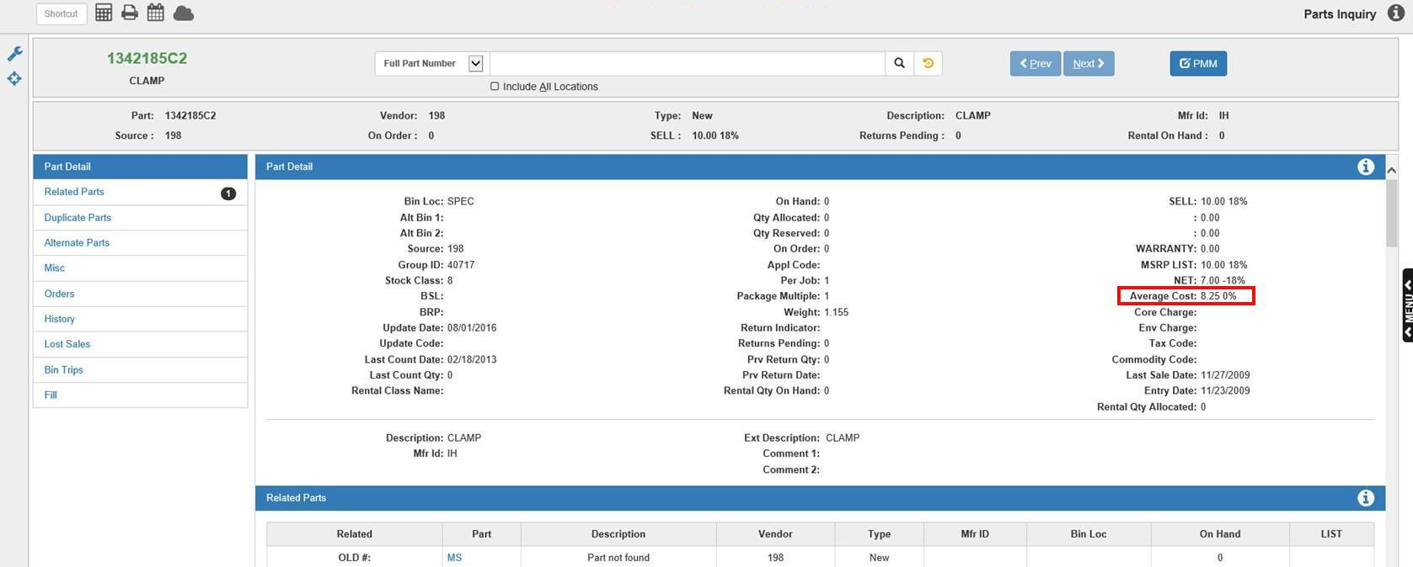

The Average Cost field is where the system stores the Average Cost and is used when making GL entries for the part cost when posting part sales. This field is also used anywhere the system is calculating the cost: IMP, PVR, PI, and Orders.

### Orders: When placing an order either by SSO, CSO, QOA, POS, or ROM, the system calculates the value of the order by multiplying the order quantity by the Mfr Cost.

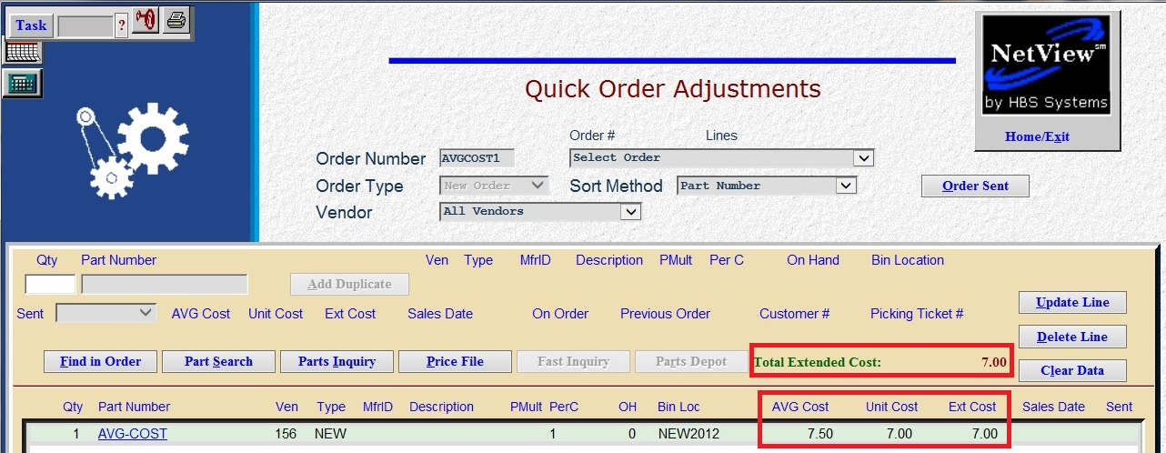

The order is placed and the part arrives. You will receipt the part into inventory. With Average Cost turned on, you can enter a discount if the order receives a special discount. The Received Cost is the Mfr Cost from PMM, also known as the Replacement Cost. The system will discount the Received Cost by this percentage automatically. If no discount applies the user enters the new cost in the Received Cost field. The program will calculate the new Average Cost.

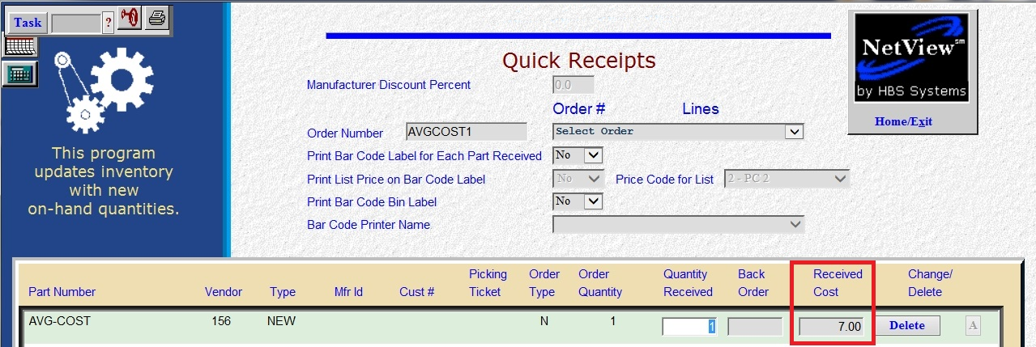

In this example the original Mfg. Cost is $7.00, and the new Received Cost is $8.00. Follow along to see what happens to the Average Cost.

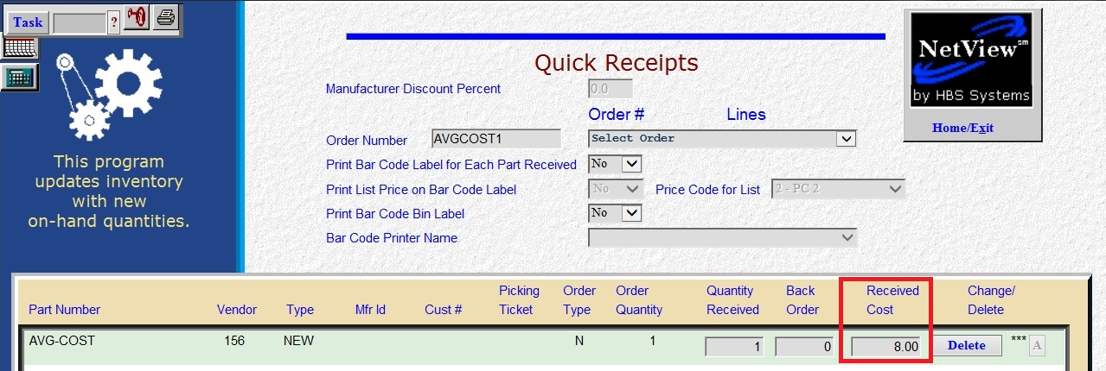

When the QR is completed the printout will look like this. Since there was zero on hand to start with, the new Average Cost is $8.00. The total cost of the order is $8.00.

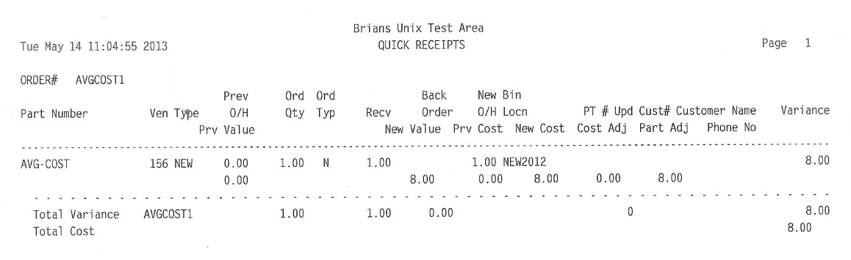

The same part is ordered again. Notice the Average Cost is now $8.00, but the Total Extended Cost is $7.00. We show the Extended Mfr Cost or Replacement Cost so you can determine if the order qualifies for the vendor discounts and terms as the vendor is pricing their parts off the Mfr Cost in PMM.

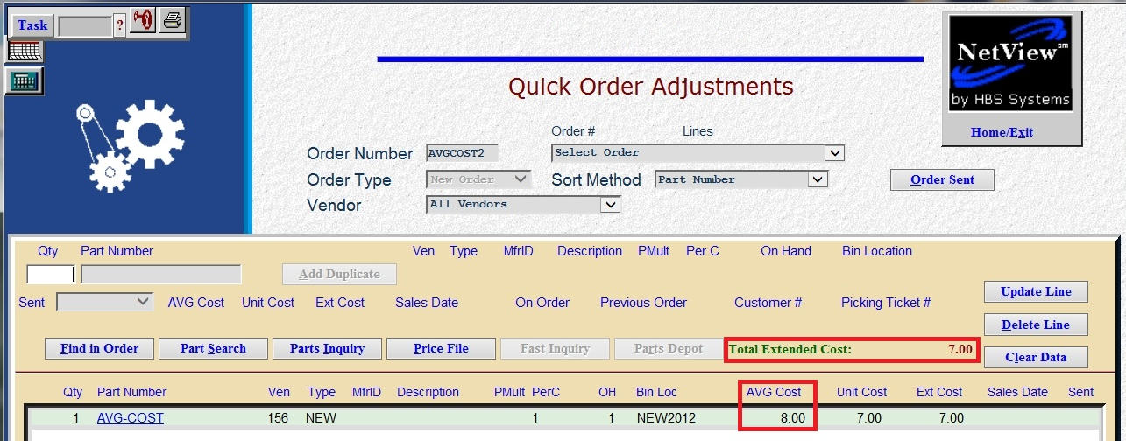

In this example the original cost is 7.00 (this is the Mfr Cost in PMM).

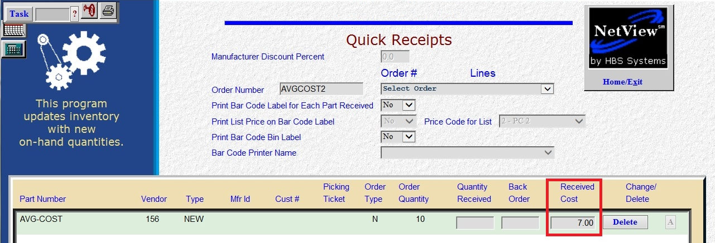

The Receiving Cost is changed to $8.50 to demonstrate what happens to the Average Cost when the parts are received with a new cost.

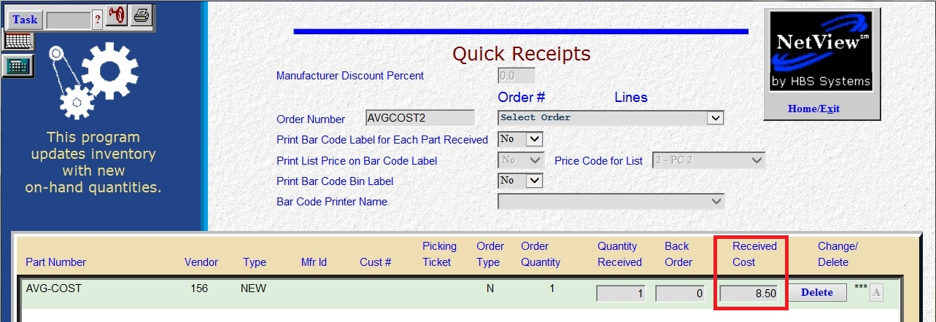

When the QR is completed the printout will look like this.

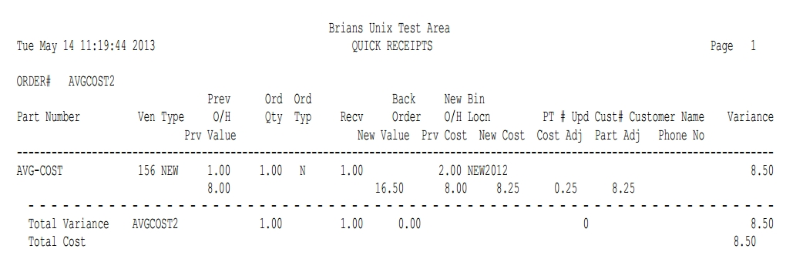

### Calculation of Average Cost: The method is straightforward:

* The on hand quantity is multiplied by the Average Cost.

1 X 8.00 = 8.00

* The number of parts to add to inventory is multiplied by the new replacement cost.

1 X 8.50 = 8.50

* The two dollar amounts are added together.

8.00 + 8.50 = 16.50

* The on hand quantity is incremented by the additional number of parts.

1 + 1 = 2

* The dollar total is then divided by the total number of units now on hand giving the new Average Cost.

16.50 / 2 = 8.25 – This matches the Avg Cost on the test part in PMM.